FunctionsCOP 3223 Assignment 4

Title: Functions

Zachary Taylor

Watch the 2 video segments on functions: 11, 12

- Write a function that takes an array of ints, and the size of the array – another int. It also returns a double. Call this one ‘average.’ Return a double that is the average of the values in the array. Demonstrate that it works by finding the average of an array with these values {78, 90, 56, 99, 88, 68, 92}
- Write a function that takes one double parameter, and returns a char. The parameter represents a grade, and the char represents the corresponding letter grade. If you pass in 90, the char returned will be ‘A’. If you pass in 58.67, the char returned will be an ‘F’ etc. Use the grading scheme on the syllabus for this course to decide what letter to return.
- Write a function that takes 3 int arguments and returns the largest of the 3.

Deliverables: Submit the following materials:

Paste each program into this document - that is correctly indented and commented, and followed immediately by the output from testing that program. Please upload the file to webcourses when done.

PART 1:

//Zachary Taylor
//11/20/2019
//Functions - Averages

#include <stdio.h>
#include <string.h>

int main(){

double size1, average;
int size2, array[7];

//collects values
printf("Please input 7 values.\n");
scanf("%ld",&array[0]);
scanf("%ld",&array[1]);
scanf("%ld",&array[2]);
scanf("%ld",&array[3]);
scanf("%ld",&array[4]);
scanf("%ld",&array[5]);
scanf("%ld",&array[6]);

//calculates and outputs size
size2=array[0]+array[1]+array[2]+array[3]+array[4]+array[5]+array[6]+array[7];
size1=size2;
printf("The size of the array is %lf.\n",size1);

//calculates and outputs average
average = (size1)/7;
printf("The average of the values is %lf.\n",average);

return 0;
}
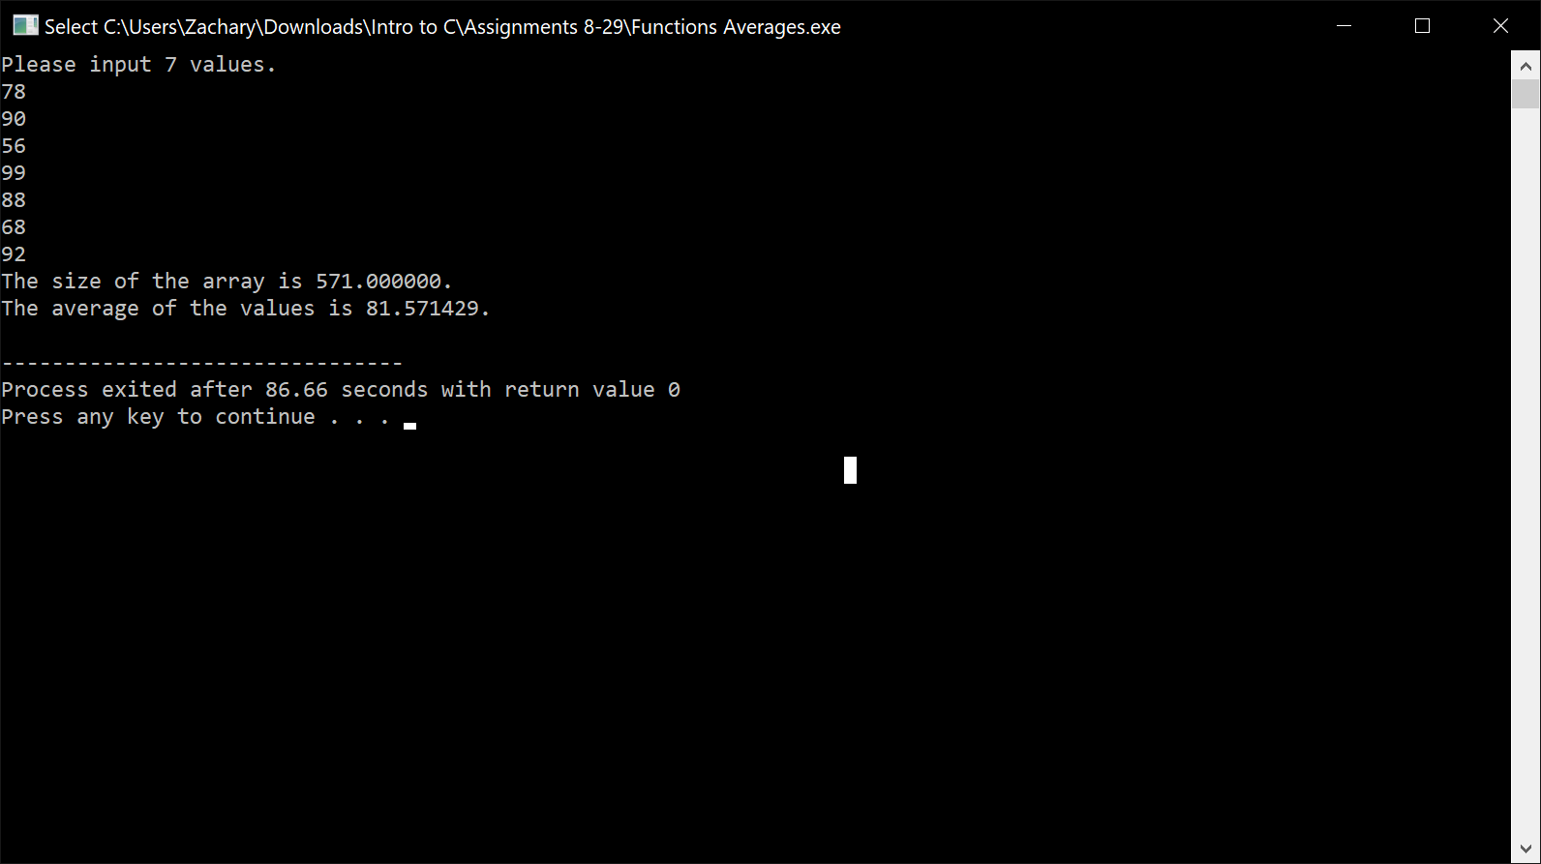

PART 2:

//Zachary Taylor
//11/20/2019
//Functions - Grades

#include <stdio.h>
#include <string.h>

int main(){
double score;
char a, b, c, d, f;
a='A';
b='B';
c='C';
d='D';
f='F';

//Score prompt & recording
printf("Please input your score to receive a letter grade.\n");
scanf("%lf",&score);

//Scores returned with grade responses

if(score<61){
printf("%c",f);
}
if(score<70 && score>60){
printf("%c",d);
}
if(score<80 && score>70){
printf("%c",c);
}
if(score<90 && score>80){
printf("%c",b);
}
if(score<=100 && score>=90){
printf("%c",a);
}

return 0;
}
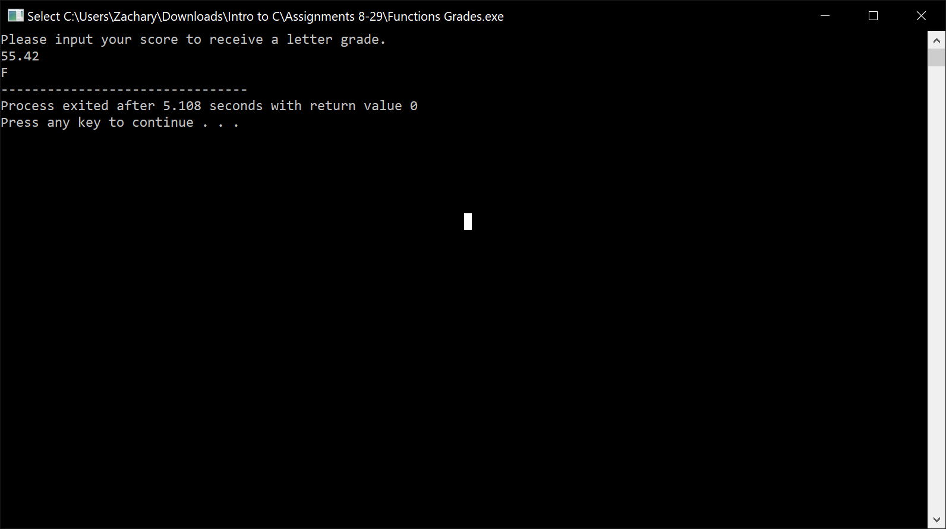
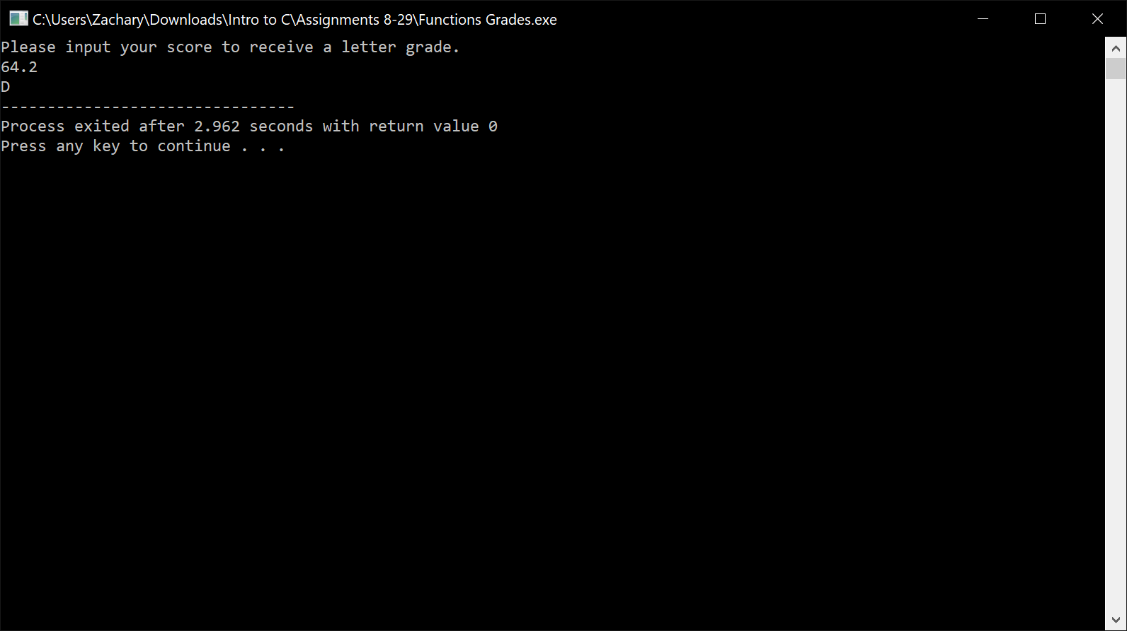

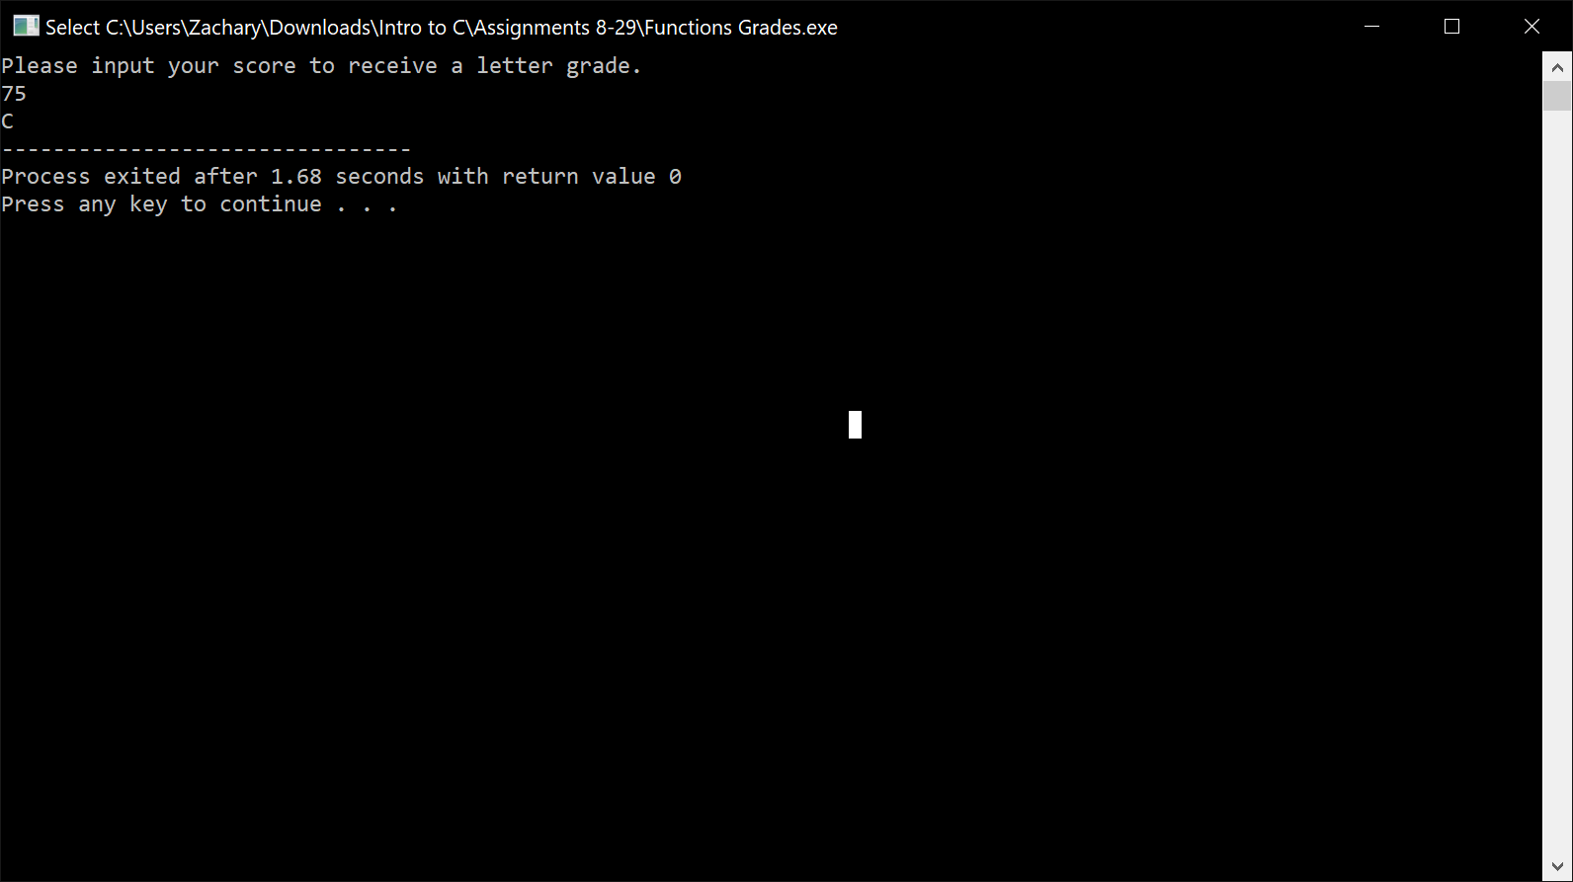
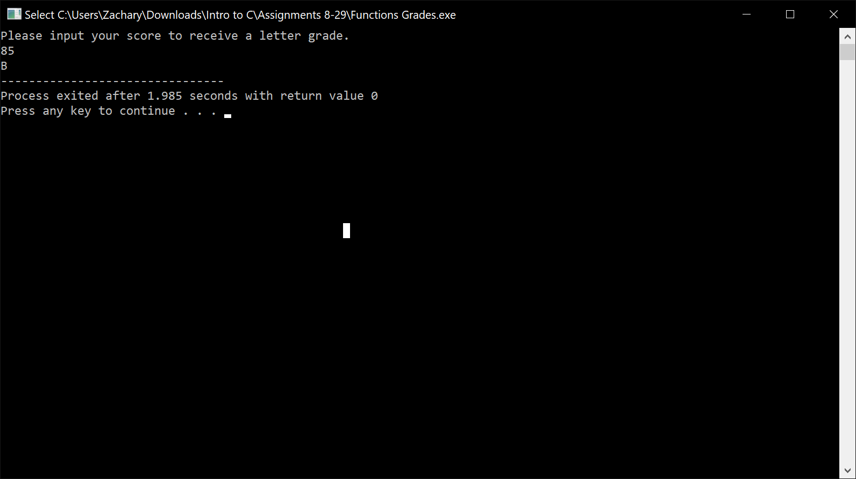
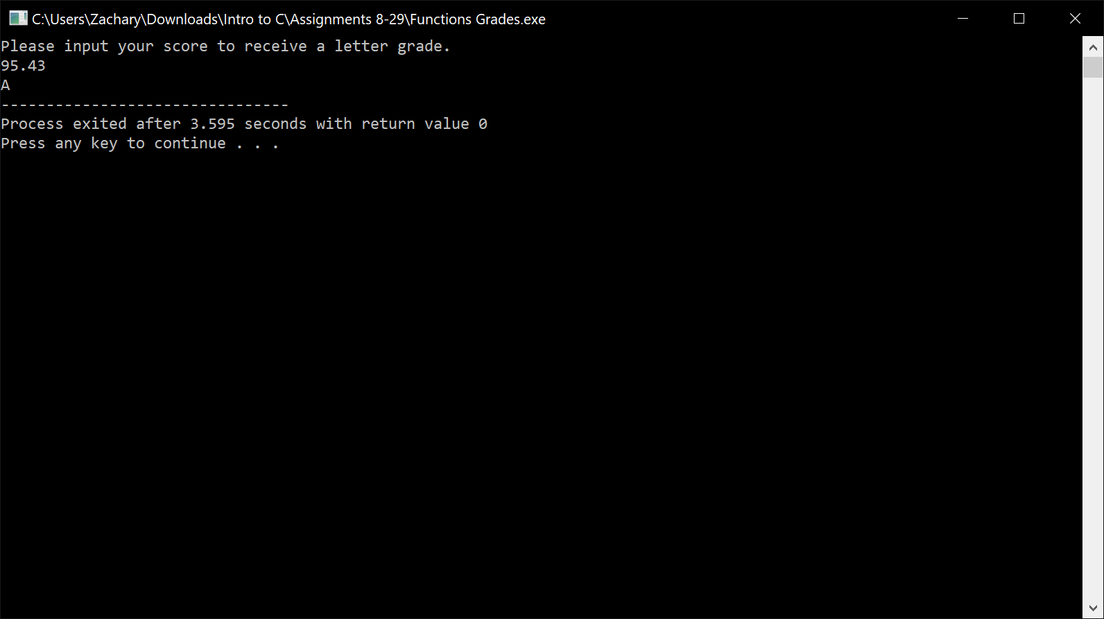

PART 3:

//Zachary Taylor
//11/20/2019
//Functions - Function returns largest of 3

#include <stdio.h>
#include <string.h>

int main(){

//3 arguments
char arg1[10]="tempest";
char arg2[10]="zephyr";
char arg3[10]="cloud";

//comparing int
int large1 = strncmp(arg2,arg1,6);
int large2 = strncmp(arg3,arg1,5);
int large3 = strncmp(arg3,arg2,5);

//outputting results
if(large1>large2 && large1>large3)
printf("The largest argument is %d, the argument tempest.",large1);
if(large2>large1 && large2>large3)
printf("The largest argument is %d, the argument zephyr.",large2);
if(large3>large1 && large3>large1)
printf("The largest argument is %d, the argument cloud.",large3);

return 0;
}

